Volvo C40 High-Tech Headlights-

**Smart LED pixel light**

The headlight in the new C40 combines daytime running light, position light and turn signal light in a particularly compact form. An adaptive lighting system with camera and radar sensor ensures a high level of road safety by optimally illuminating the road without dazzling oncoming traffic. This is achieved by individually controllable LEDs combined in the pixel module. A front camera and the radar eye detect oncoming vehicles or vehicles in front and activate or deactivate the LED light in the headlamp's pixel module via the control unit. Despite the compact dimensions of the front headlamp, the system achieves a high light output. The unique LED light was developed in Wieselburg, where the headlight is also manufactured. The pixel module electronics come from the ZKW electronics plant in Wiener Neustadt.

**Super-flat projection modules**

The powerful light output of the premium headlamp is achieved by the LED pixel module in combination with the innovative ForTIR elements. The so-called light finger ForTIR elements use the apron to project part of the low beam onto the road. These are particularly flat projection modules that are just 13 millimeters high and also serve as design elements in the main headlights. The front headlamp's light design, typical of Volvo, has the characteristic "Thor's Hammer" shape, in which special attention was paid to homogeneity. This design element is formed via the light guides and thick-wall optics in front of it, and unmistakably represents the C40 as a Volvo. "The combination of 84-LED pixel module, light finger ForTIR* elements and Thorhammer design is unique to Volvo," Steger explains. ZKW equips both the Volvo C40 and XC40 models with premium LED headlights, using the same headlight module as a basis.

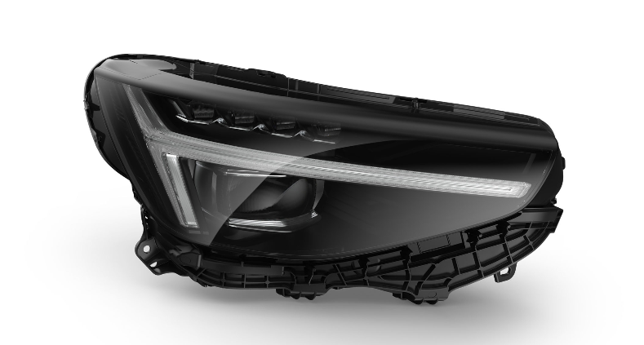

(From “https://zkw-group.com/en/home/newsroom/news/zkw-equips-new-all-electric-volvo-c40-with-high-tech-lights/”)

Volvo S60 Headlights –

The S60's optional curve-adaptive LED reflector headlights improved to a good rating on vehicles built after May 2019. The same headlights on models built earlier rate only marginal, as do the S60’s base headlights, static LEDs.

A good headlight rating is one of several requirements for a 2019 TOP SAFETY PICK+ award. A vehicle must also earn good ratings in all six IIHS crashworthiness evaluations and an advanced or superior rating for vehicle-to-vehicle front crash prevention.

The S60 earns good ratings in the driver-side small overlap front, passenger-side small overlap front, moderate overlap front, side, roof strength and head restraint tests.

The S60 comes standard with a superior-rated vehicle-to-vehicle front crash prevention system. In track tests, the system avoided a collision with a fixed object representing the rear of another vehicle in the 12 mph test, and it reduced its impact speed by an average of 22 mph in the 25 mph test.

Pedestrian front crash prevention doesn't factor into 2019 safety award criteria, but the S60 has been evaluated and earns a superior rating for its standard system. In four of six pedestrian scenarios, the S60 avoided a collision completely. When tested at 25 mph in the crossing child scenario, the S60 reduced its impact speed by an average of 19 mph. When tested at 37 mph in the parallel adult scenario, the S60 reduced its impact speed by an average of 27 mph.

Pedestrian crash prevention ratings will factor into IIHS award criteria for the first time in 2020.

(From “https://www.iihs.org/news/detail/2020-volvo-s60-improves-headlights-earns-highest-safety-award”)